**Assignment 1**

**Data Exploration and Classification**

**Semester 1 2024**

**Student Name: William Bank Sukjaem**

**Student ID: 18029208**

## **PAPER NAME:** Foundations of Data Science

**PAPER CODE:** COMP615

**Due Date:** Sunday 14 April 2024 (midnight)

**TOTAL MARKS:** 100

**Instructions:**

1. **The following actions** may be deemed to constitute a breach of the General Academic **Regulations Part 7: Academic Discipline,**

* Communicating with or collaborating with another person regarding the Assignment
* Copying from any other student work for your Assignment
* Copying from any third-party websites unless it is an open book Assignment
* Uses any other unfair means

1. **Please email** [**DCT.EXAM@AUT.AC.NZ**](mailto:DCT.EXAM@AUT.AC.NZ) **if you have any technical issues with your Assessment/Assignment/Test submission on Canvas immediately**
2. **Attach your code for all the datasets in the appendix section**.

Contents

**PAPER NAME:** Foundations of Data Science 1

Introduction to the dataset 2

1. Data Exploration 2

2. Data Classification Models 6

3. Results and Discussion (400-500) 7

References 7

# Introduction to the dataset

The chosen data covers the topic of Maternal Health Risks in pregnant women with the data being collected from different maternal health care places in rural areas of developing countries, more specifically Bangladesh. The research relevant to the dataset analyses biometric data from wearable IoT devices from women during maternity with the goal being to identify, compare, and analyse relationships between the collected biometric data to mitigate and/or reduce maternal health risks. This analysis is under the assumption that the dataset used is accurate and that the women sampled are healthy.

# Data Exploration

**1.1 Data Types and Statistics Summary**

The data set consists of 1014 instances and 7 attributes where 4 of the attributes are of type integer, 2 of type float, and 1 of type object. Six of the seven attributes are numerical being Age, SystolicBP, DiastolicBP, BloodSugar, BodyTemp, and HeartRate while the remaining is categorical being RiskLevel.

To briefly explain these attributes. The systolic blood pressure and diastolic blood pressure is the upper and lower values of blood pressure, respectively, which is measured in millimeter of mercury (mmHg). Blood sugar, which measures blood glucose levels (mmol/L), and body temperature, measured in Fahrenheit (°F).

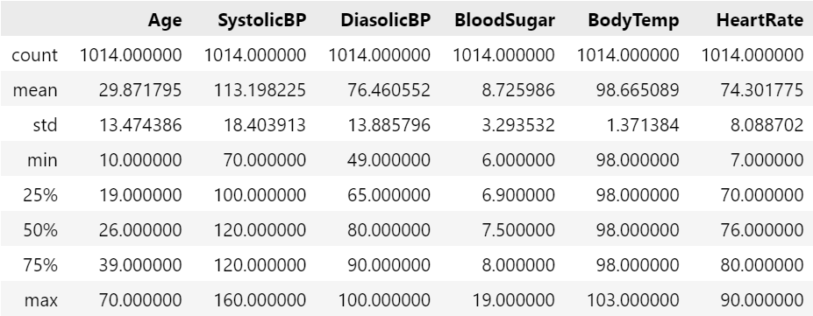

Figure 1: Summary Statistics of continuous numerical features

The summary statistics in figure 1 provides key insight into biometric data of women in maternity and interesting statistical data. It is important to note that some of the data is not fully representative of the general population of women in maternity since the collection of data for the dataset was conducted within a single country.

In this dataset, the mean age of women in maternity is 29.8 years old with the lowest being 10 and maximum being 70. In this case, the minimum and maximum age are on the extreme ends of the spectrum which in reality will be quite rare when comparing amongst the general population indicating potential outliers. The mean age is normal when comparing to New Zealand’s average age of mothers at the time of child birth (Statistica, 2023).

The mean blood sugar level is 8.7 mmol/L, with the median being 7.5 mmol/L. The minimum and maximum values are 6.0 mmol/L and 19.0 mmol/L, respectively. The blood sugar values have an extremely large range of 13 mmol/L.

According to the Mayo Clinic, an academic medical center, the baseline maximum for blood sugar level in pregnant women is around 7.8 mmol/L. This places the median within the range for normal blood sugar levels, while levels greater than 11.1 mmol/L show signs of diabetic blood sugar levels (Mayo Clinic, 2024). Although some values lie above 11.1mmol/L, some are well beyond the range of blood sugar levels of severe diabetic cases. The mean has a high value due to it being skewed by the high maximum value.

The mean heart rate is 74.3 bpm where the minimum is 7.0 bpm and maximum being 90 bpm. The minimum heart rate is abnormally low and is most likely an outlier. Heart rate is slowest when a person is sleeping which puts the heart rate at around 40 to 60 bpm. The range for heart rate is extremely large at 87 bpm.

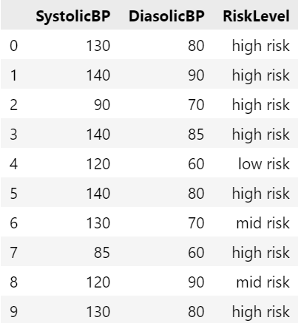

Figure 2: Table comparing Blood Pressure to Risk Level

For the blood pressure values, the mean SystolicBP is 113.20mmHg and DiasolicBP is 76.46mmHg. For the minimum and maximum, SystolicBP has values of 70mmHg and 160mmHg, and DiasolicBP has values of 49mmHg and 100mmHg. The mean values for blood pressure is normal and within the expected range healthy range of 120mmHg and 70mmHg or lower (Heart Foundation, n.d). However, when blood pressure exceeds 120mmHg, there is an overall higher risk of health complications shown when comparing RiskLevel to SystolicBP and DiasolicBP seen in figure 2 that shows first 10 rows of the dataset. High blood pressure is seen in women 20 weeks before or after who have Chronic Hypertension or Preeclampsia which is a serious disorder resulting from high blood pressure (ACOG, 2022). These abnormally high values, where SystolicBP is greater than 140mmHg, may be potential outliers in the dataset.

**1.2 Dataset Cleanliness**

Figure 3: Missing Values

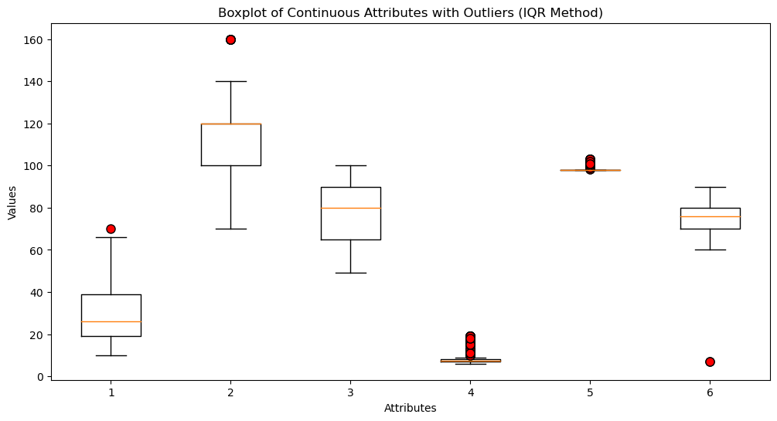

Figure 4: Boxplot of Continuous Attributes with identified outliers

In figures 3 and 4 helps in determining the cleanliness of the dataset. Figure 3 shows that there are no missing data in each attribute and in figure 4 shows the distribution of data points across each continuous attribute.

Upon looking at figure 4 and based on previous analysis on the statistics summary, there are certainly outliers that are not within reason of the general sample population of the dataset due to their extreme variance relative to the mean in their respective categories.

Figure 5: Boxplot of Continuous Attributes without Outliers

Since the box plots in figure 4 do not show signs of normality because of its asymmetry, the method of choice that is used to identify the outliers is the IQR method. The detected outliers are seen as red circles and are removed to have a cleaner dataset and better represent the general sample population as seen in figure 5.

The choice to remove these outliers are because these points lie greatly beyond what the human body would show in terms of biometrics. These cases are extremely unlikely to occur under the assumption that the women in the sample population are healthy. An example of this can be clearly seen through two categories: Heart Rate and Blood Sugar. The outliers for Blood Sugar go well beyond 11.1mmol/L which is extremely high even for diabetics and for heart rate, 7 bpm is extremely abnormal for high stress situations.

**1.3 Illustration and Explanation of Features**

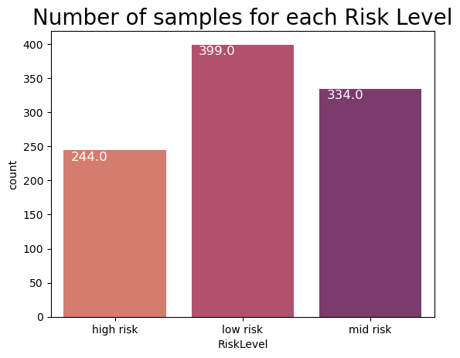

Figure 6: Count for each Risk Level

The risk levels in figure 7 show that most of the sample population of women are at a low or medium health risk when in maternity. There are still a significant amount of women at a high risk but relative to the overall sample population, only 22.9% are at a high risk.

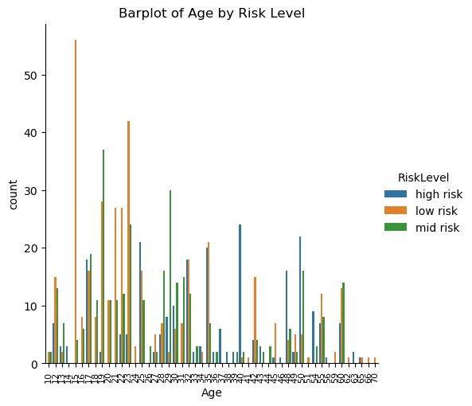

Figure 7: Age by Risk Level

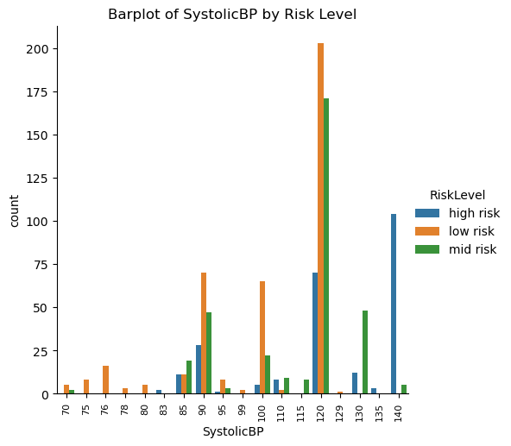

Figure 8: Systolic Blood Pressure by Risk Level

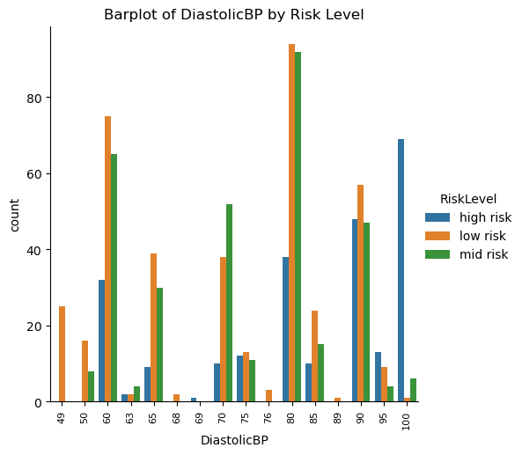

Figure 9: Diastolic Blood Pressure by Risk Level

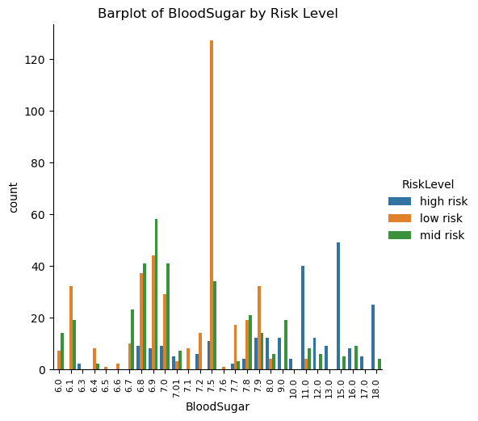

Figure 10: Blood Sugar by Risk Level

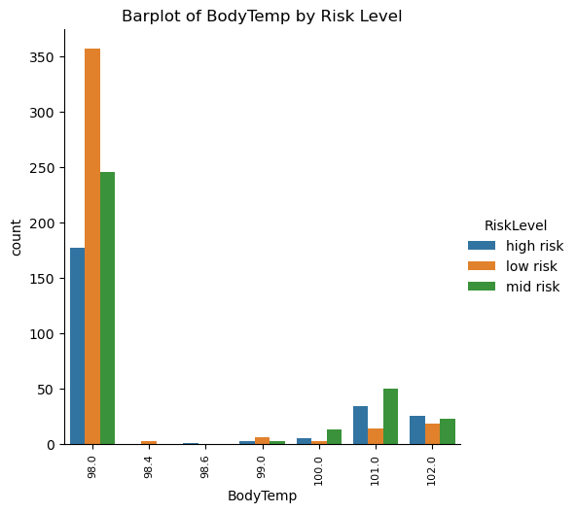

Figure 11: Body Temperature by Risk Level

Figure 12: Heart Rate by Risk Level

Risk level in terms of age, there is a trend indicating increasing levels of health risks as you get older.

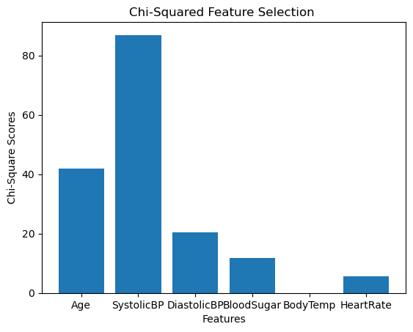

Figure 13: Chi-Squared Feature Selecton Bar plot

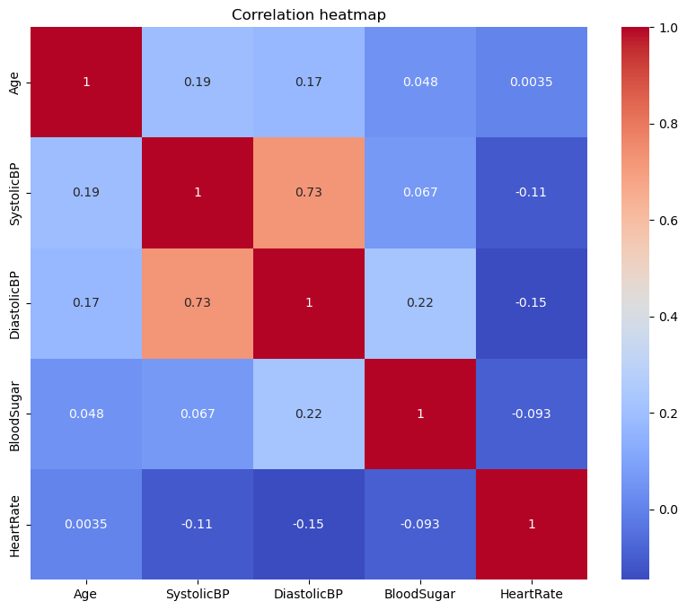

* ~~Histogram of Risk Count~~
* ~~Heatmap show some correlation between cont attributes~~
* ~~Histogram of RiskLevel vs Continuous Attributes~~
* Chi Square Score
* Box plots

*This section of your report must discuss the dataset and any features you consider relevant to the analysis and modelling task.*

*~~• How many features (attributes) and instances exist, and what data types are these?~~*

*• ~~Provide summary statistics of the continuous numerical features.~~*

*~~• Perform an initial exploration of the provided dataset to assess its cleanliness. Describe the steps taken to address both data cleanliness evaluation and data cleaning strategies.~~*

*• ~~Illustrate the features of your dataset using meaningful boxplots, histograms and grouped scatter plots (remember, these plots allow you to analyse the individual distribution of features and the relationship between them).~~*

*• Explain what you can learn from your data exploration and visualisations provided*

# Data Classification Models

*You need to create a model using the* ***Decision Tree Classifier*** *and answer the following questions based on the model built. In building the model, use the 10-fold cross-validation option for testing. Your answers need to be supported by suitable evidence, wherever appropriate. Some examples of suitable evidence are Confusion Matrices, Model Visualizations, and Model Summary Reports.*

*a) You are required to report your preprocessing steps. The steps should include identifying any missing/duplicate data or outliers. Provide explanations of how you dealt with them.*

*[****5 marks]***

*b) Find the feature importance based on the final classification model and explain your findings. [****5 marks****]*

*c) Create a model using the Decision Tree algorithm. Adjust* ***two*** *suitable parameters (one at a time) to reduce the tree's size and improve your model's accuracy. Report the accuracy score for each parameter using the plots. Provide the final optimised classification tree and describe its structure. [****12 marks]***

*d) Describe the role of the two parameters in the model building you used in part a) above. Do you expect that using the same values obtained for this dataset will improve the accuracy of other datasets? Justify your answer. [****8 marks]***

*e) Generate and carefully examine the Confusion Matrix and explain your findings. Provide the model summary report and discuss the metrics (accuracy, precision, recall, and F1-score).* ***[10 marks]***

# Results and Discussion (400-500)

# References

American Congress of Obstetricians and Gynecologists. (2020). Preeclampsia and High Blood Pressure During Pregnancy. <https://www.acog.org/topics/hypertension-and-preeclampsia-in-pregnancy>

American Heart Association. (2023). High Blood Pressure. <https://www.heart.org/en/health-topics/high-blood-pressure>

Diabète Québec. (n.d.). Diabetes in Pregnancy. <https://guidelines.diabetes.ca/cpg/chapter36>

Heart Foundation New Zealand. (n.d.). Managing High Blood Pressure. <https://www.heartfoundation.org.nz/wellbeing/managing-risk/managing-high-blood-pressure>

Mayo Clinic. (2023). Diabetes Diagnosis. <https://www.mayoclinic.org/diseases-conditions/diabetes/diagnosis-treatment/diagnosis/dxc-20371445>

MedlinePlus. (2021). High Blood Pressure. <https://medlineplus.gov/ency/anatomyvideos/000072.htm>

National Institute of Diabetes and Digestive and Kidney Diseases. (2022). Diabetes. <https://www.niddk.nih.gov/health-information/diabetes>

Statista. (2023). New Zealand: Median age of mothers at childbirth from 1990 to 2023. <https://www.statista.com/statistics/1064536/new-zealand-fertility-rate-by-age-group/>

[**https://www.heart.org/en/health-topics/high-blood-pressure**](https://www.heart.org/en/health-topics/high-blood-pressure)

[**https://www.niddk.nih.gov/health-information/diabetes**](https://www.niddk.nih.gov/health-information/diabetes)

[**https://medlineplus.gov/ency/article/001982.htm**](https://medlineplus.gov/ency/article/001982.htm)

[**https://www.statista.com/statistics/1081327/new-zealand-median-age-of-mothers-at-childbirth/**](https://www.statista.com/statistics/1081327/new-zealand-median-age-of-mothers-at-childbirth/)

[**https://www.heartfoundation.org.nz/wellbeing/managing-risk/managing-high-blood-pressure**](https://www.heartfoundation.org.nz/wellbeing/managing-risk/managing-high-blood-pressure)

[**https://www.acog.org/womens-health/faqs/preeclampsia-and-high-blood-pressure-during-pregnancy#:~:text=You%20have%20gestational%20hypertension%20when,normal%20blood%20pressure%20before%20pregnancy**](https://www.acog.org/womens-health/faqs/preeclampsia-and-high-blood-pressure-during-pregnancy#:~:text=You%20have%20gestational%20hypertension%20when,normal%20blood%20pressure%20before%20pregnancy)**.**

[**https://www.diabete.qc.ca/en/diabetes/information-on-diabetes/diabetes-in-pregnancy/**](https://www.diabete.qc.ca/en/diabetes/information-on-diabetes/diabetes-in-pregnancy/)

[**https://www.mayoclinic.org/diseases-conditions/diabetes/diagnosis-treatment/diagnosis/dxc-20371445**](https://www.mayoclinic.org/diseases-conditions/diabetes/diagnosis-treatment/diagnosis/dxc-20371445)